ELEGANT DESIGNS FOR YOUR WINDOWS WILL BE TAKEN TO THE NEXT LEVEL FOR PERFORMANCE USING **AMS** PRODUCTS.CUSTOM ,MANUAL & MOTORIZED ROLLER SHADES - ROMAN SHADES - HORIZONTAL SHADING - WOVEN WOOD BLINDS - HONEYCOMB SHADES - DRAPERY TRACKS - STANDARD & SPECIALTY SHADESMOTORIZATION CAN BE DONE USING INDIVIDUAL. REMOTE CONTROLS OR DIRECT INTEGRATION WITH ANY HOME AUTOMATION SYSTEM.ALL DONE WITH 35 YEARS OF EXPERIENCE AS A MANUFACTURER.BUILT ON A FOUNDATION OF 3 GENERATIONS WORKING IN THE WINDOW TRADE INDUSTRY

SHADES

**[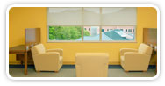](http://www.phifer.com/Commercial.aspx)**

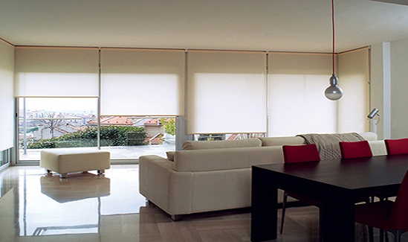

HONEYCOMB

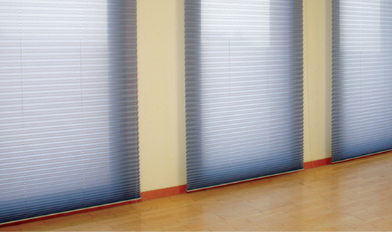

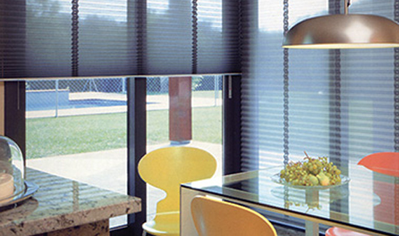

WOOD BLINDS

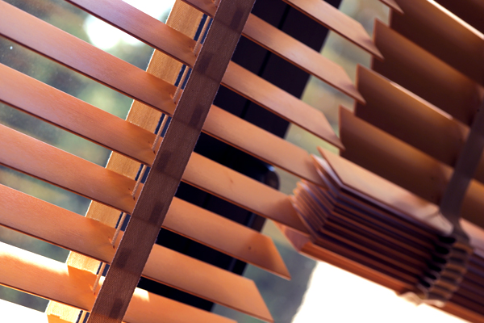

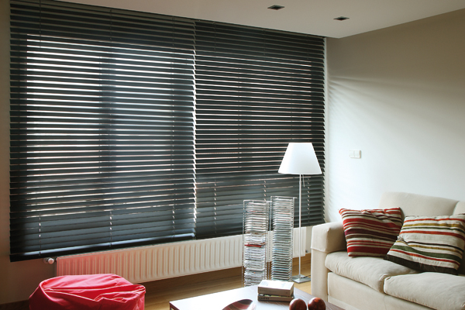

MOTORIZED DRAPERY RODS

